Praktijkopdrachten

Mohamed Derrazi

6-2-2025

Ticket 1:

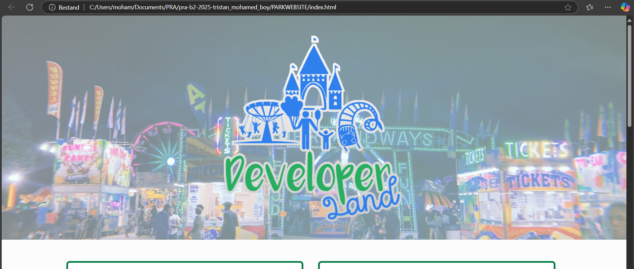

Ticket 3:

Ticket 5:

Ticket 8:

Ticket 13: